Challenge 4 - Finance Analysis



Intro

You are a Finance Analyst working for 'The Big Bank'

You have been tasked with finding out about your customers and their banking behaviour. Examine the accounts they hold and the type of transactions they make to develop greater insight into your customers.

Tables

Here are the tables you will be using

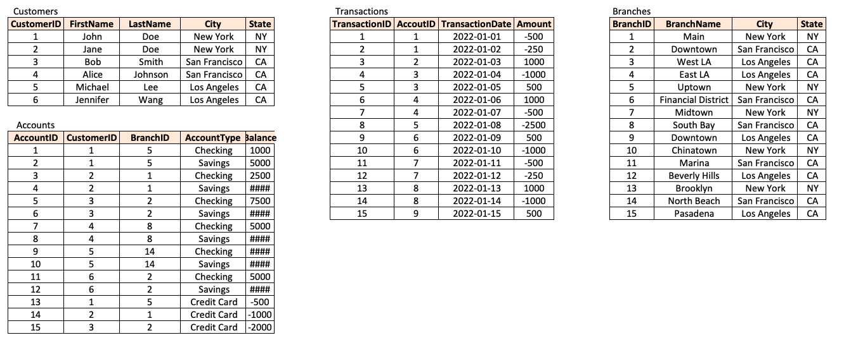

Questions

Answer the following questions

Then write a LinkedIn post saying what you have learnt or enjoyed

1. What are the names of all the customers who live in New York?

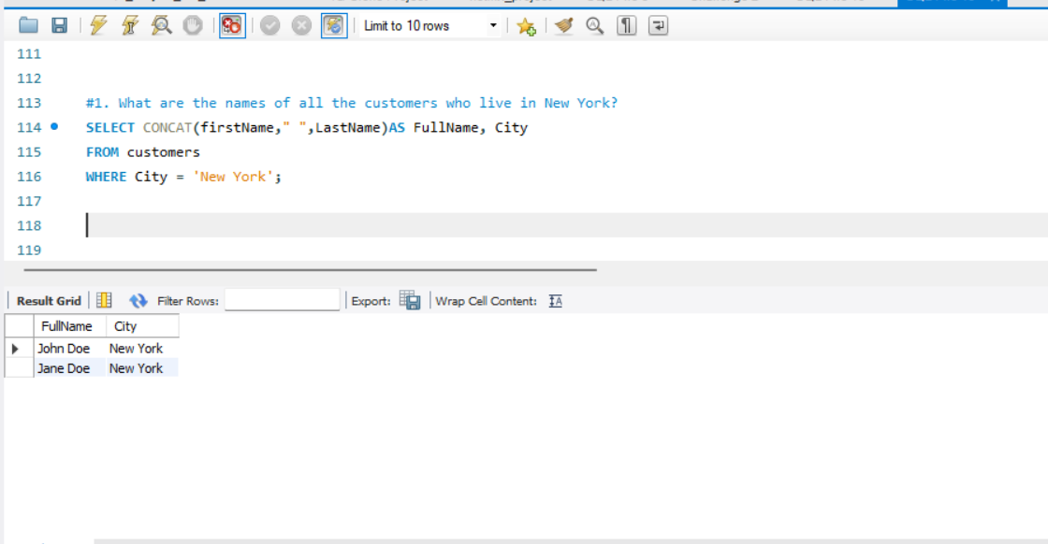

2. What is the total number of accounts in the Accounts table?

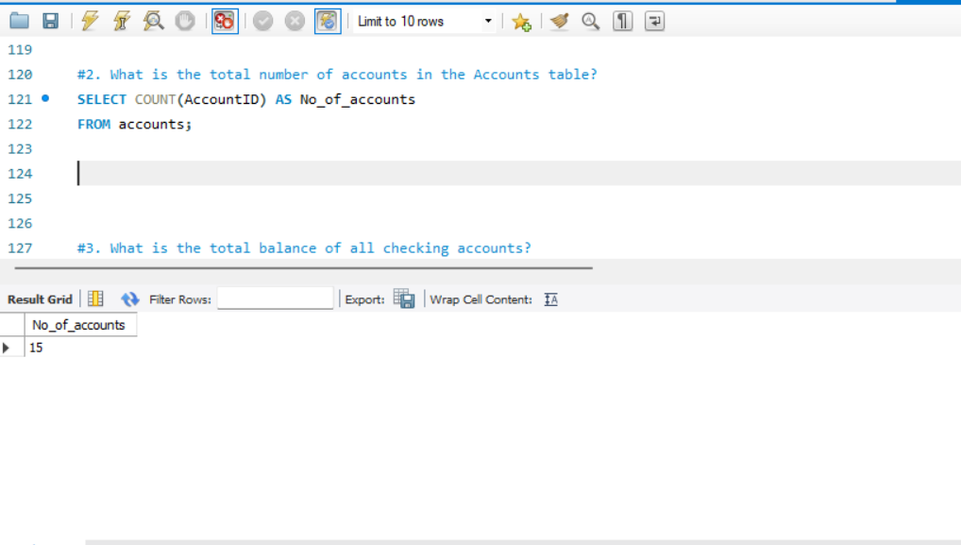

3. What is the total balance of all checking accounts?

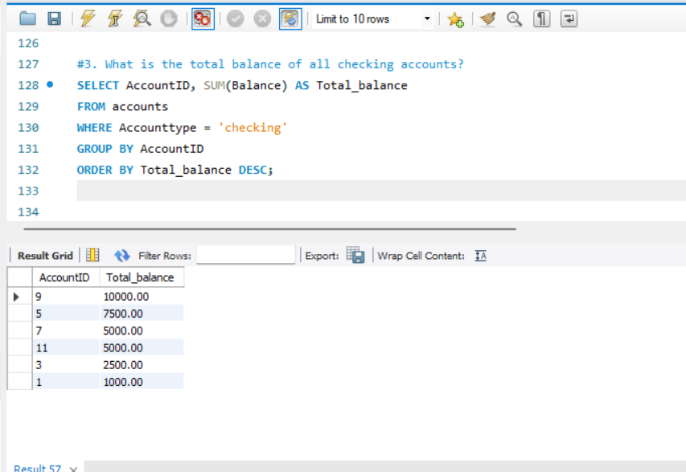

4. What is the total balance of all accounts associated with customers who live in Los Angeles?

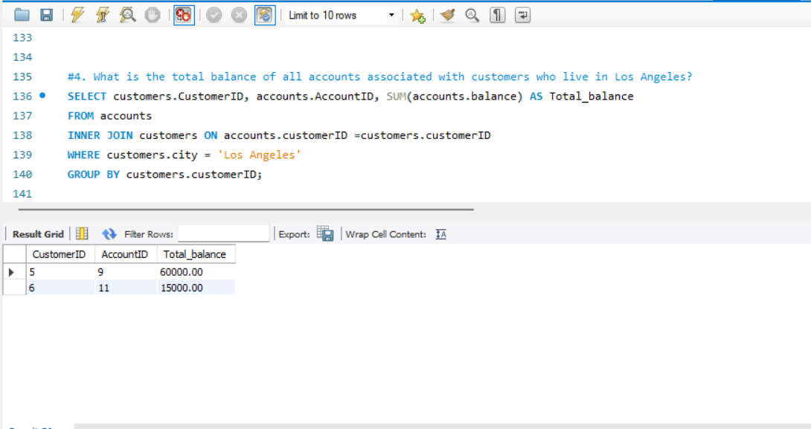

5. Which branch has the highest average account balance?

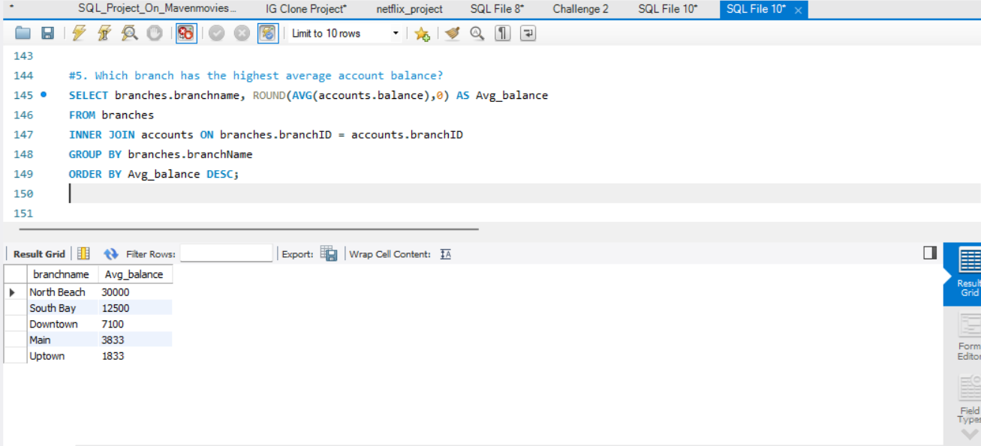

6. Which customer has the highest current balance in their accounts?

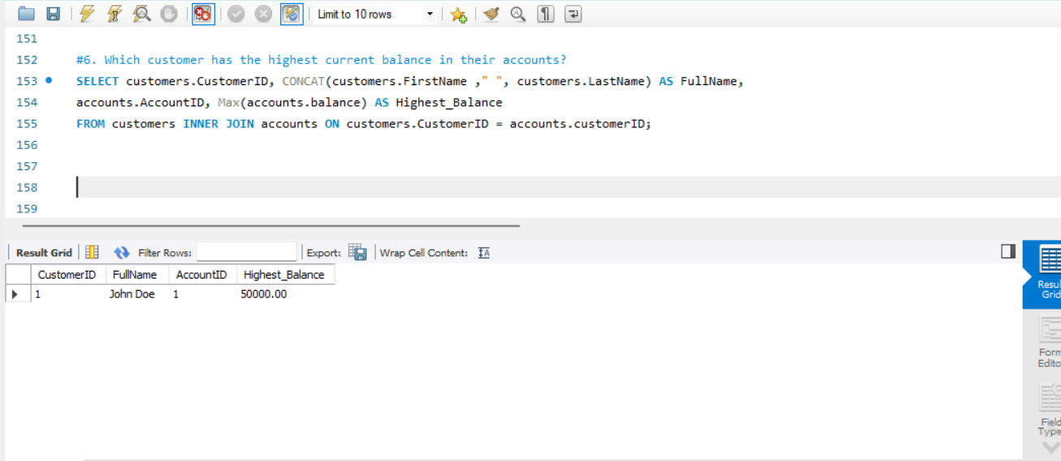

7. Which customer has made the most transactions in the Transactions table?

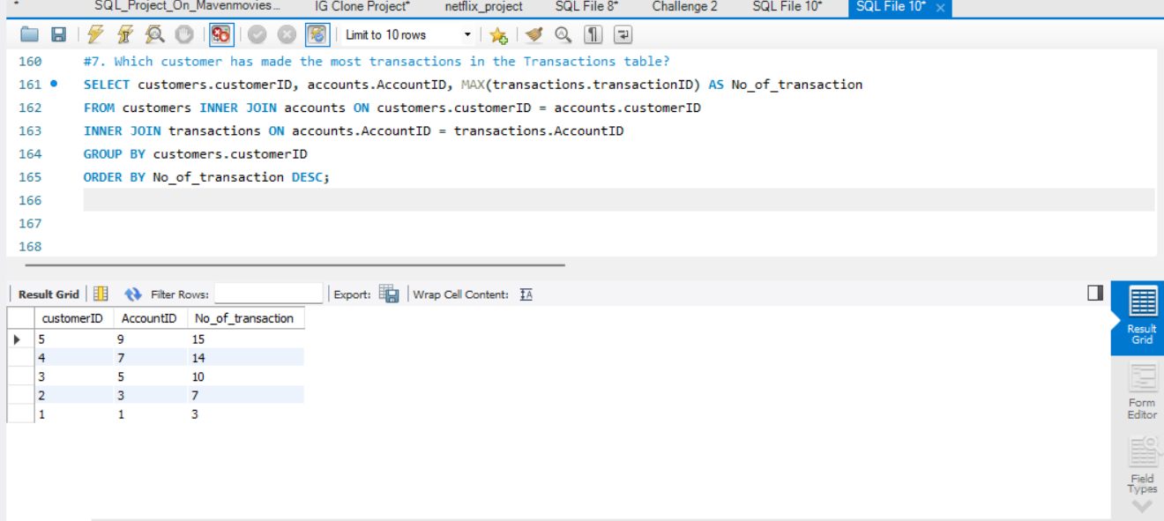

8.Which branch has the highest total balance across all of its accounts?

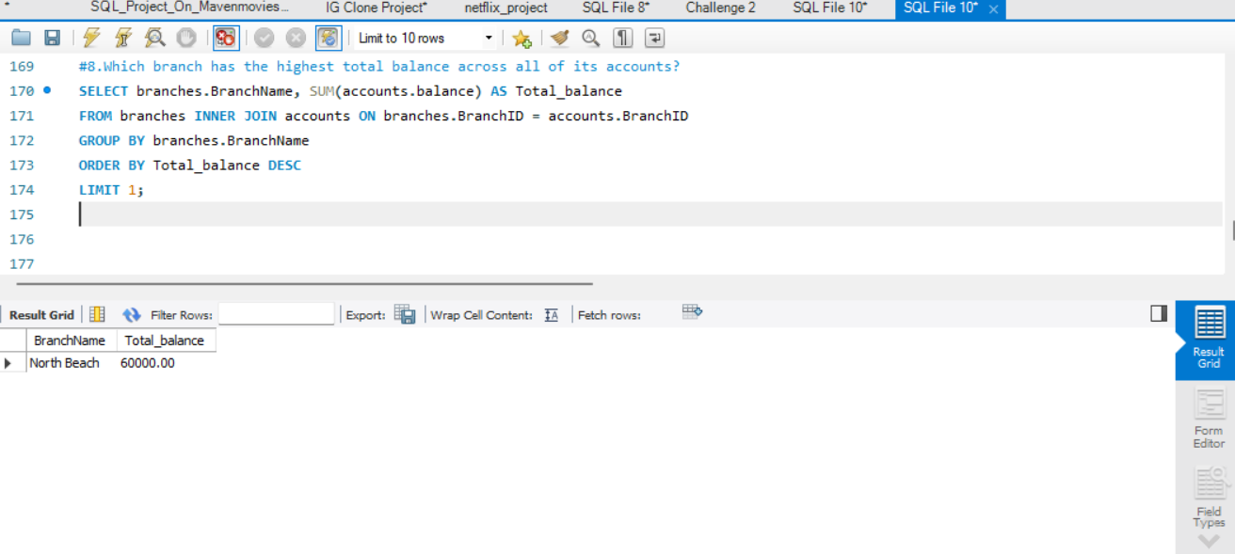

9. Which customer has the highest total balance across all of their accounts, including savings and checking accounts?

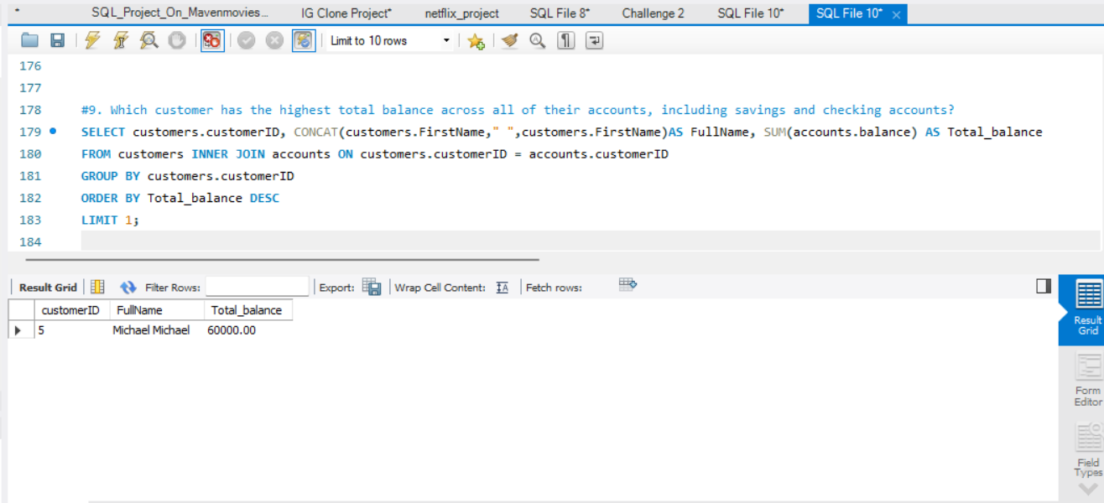

10. Which branch has the highest number of transactions in the Transactions table?

